 | 12.1.14 Editors - Geometry Nodes Editor - Header - Add Menu - Geometry - Operations
Table of content
Detailed table of content 1
Add menu - Geometry - Operations 3
Bake 4
Bounding Box 6
Convex Hull 7
Delete Geometry 7
Duplicate Elements 8
Sort Elements 8
Merge by Distance 9
Transform Geometry 10
Separate Components 11
Separate Geometry 12
Split to Instances 12

Detailed table of content
Detailed table of content
Detailed table of content 1
Add menu - Geometry - Operations 3
Bake 4
Input 4
Geometry 4
Properties 4
Animation / Still 4
Operators 4
Bake 4
Delete Geometry Node Bake 4
Output 5
Geometry 5
Sidebar content 5
Bake Packed 5
Unpack Geometry Node Bake 5
Delete Geometry Node Bake 5
Bake Target 6
Inherit from modifier 6
Packed 6
Disk 6
Custom path 6
Custom Range 6
Data Block Reference subpanel 6
Bounding Box 6
Inputs 6
Geometry 6
Output 6
Bounding Box 6
Min 6
Max 6
Convex Hull 7
Inputs 7
Geometry 7
Output 7
Convex Hull 7
Delete Geometry 7
Inputs 7
Geometry 7
Selection 7
Properties 7
Domain 7
Mode 7
Output 7
Geometry 7
Duplicate Elements 8
Inputs 8
Geometry 8
Selection 8
Amount 8
Properties 8
Domain 8
Output 8
Geometry 8
Duplicate Index 8
Sort Elements 8
Input 8
Geometry 8
Selection 8
Group ID 9
Sort Weight 9
Properties 9
Domain 9
Point 9
Face 9
Edge 9
Spline 9
Instance 9
Output 9
Geometry 9
Merge by Distance 9
Input 9
Geometry 9
Selection 9
Distance 10
Properties 10
Mode 10
All 10
Connected 10
Output 10
Geometry 10
Transform Geometry 10
Mode 10
Components 10
Inputs 10
Geometry 10
Translation 10
Rotation 10
Scale 10
Output 11
Geometry 11
Matrix 11
Inputs 11
Geometry 11
Transform 11
Output 11
Geometry 11
Separate Components 11
Inputs 11
Geometry 11
Outputs 11
Mesh 11
Point Cloud 11
Curve 11
Volume 11
Instance 12
Separate Geometry 12
Inputs 12
Geometry 12
Selection 12
Properties 12
Domain 12
Outputs 12
Selection 12
Inverted 12
Split to Instances 12
Inputs 13
Geometry 13
Selection 13
Group ID 13
Properties 13
Domain 13
Outputs 13
Instances 13
Group ID 13

Add menu - Geometry - Operations
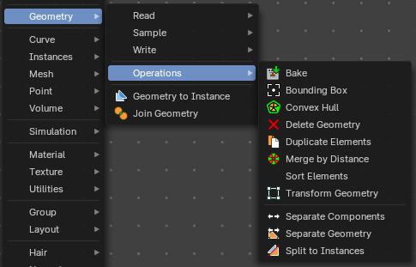
Here you find nodes to modify the geometry.

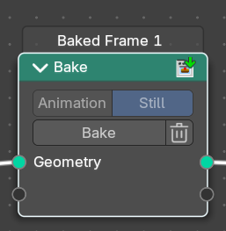
Bake
Allows saving and loading per-calculated geometry node data. This allows you to bake and “freeze” node tree parts to achieve better performance, where any data up to the node will no-longer be evaluated. Another use is to bake data for use with a render engine.
To bake, the file must be saved first.
Note: When baked, the header of the node will show how many frames have been baked.

Input

Geometry
Standard geometry input. You can bake multiple geometry inputs.

Properties

Animation / Still
Bake an animation or a single frame. Note that the bake node does not do automatic caching.

Operators

Bake
The bake operator button. Press this to bake.

Delete Geometry Node Bake
Delete baked data of a single bake node or simulation.

Output

Geometry
Standard geometry output.

Sidebar content
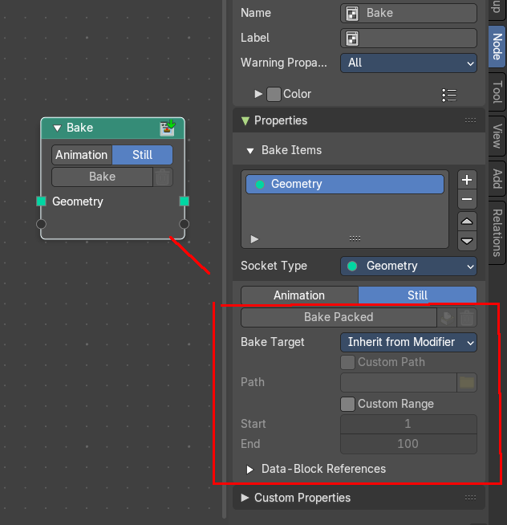
Note that this node contains also content that just shows in the sidebar. The bake packed content. It does belong to the node. And should not be disconnected from it. So we will cover it here.

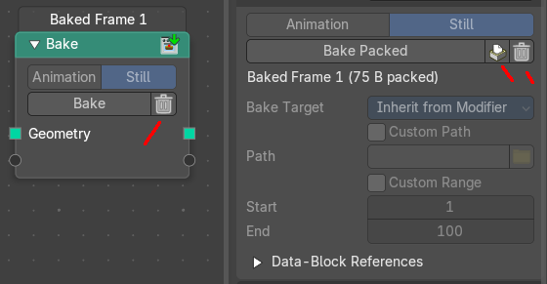
Bake Packed
Packs the baked result. Once packed, the two buttons behind the bake button becomes active. And the node shows a trashcan icon. The other content greys out since everything is now packed.

Unpack Geometry Node Bake
Unpacks the baked node content.

Delete Geometry Node Bake
Deletes the baked node content.

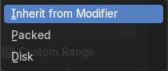
Bake Target

Inherit from modifier
Use the settings from the modifier.

Packed
Pack the data into a .blend file.

Disk
Store the baked data in a directory on a disk.

Custom path
Just for the disk method. Define a custom path for the bake.

Custom Range
Define a custom frame range for animation.

Data Block Reference subpanel
Lists referenced data if existent.

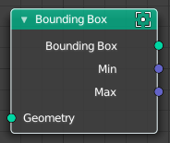
Bounding Box
The Bounding Box geometry node allows you to work with the values of a bounding box.

Inputs

Geometry
Standard geometry input.

Output

Bounding Box
Standard output.

Min
The minimum values of the bounding box.

Max
The maximum values of the bounding box.

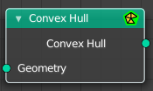
Convex Hull
The node allows you to work with the values of a convex hull of this object.

Inputs

Geometry
Standard geometry input.

Output

Convex Hull
Standard output.

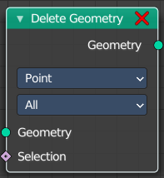
Delete Geometry
The node allows you to work with the values of a convex hull of this object.

Inputs

Geometry
Standard geometry input.

Selection
A selection of the geomerty

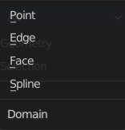
Properties

Domain
What element to delete.

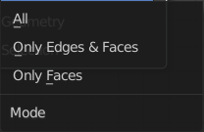
Mode
Delete mode. Names should be self explaining.

Output

Geometry
Standard output.

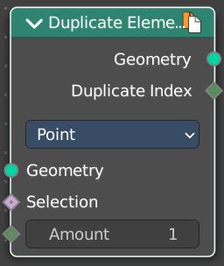
Duplicate Elements
Duplicates a part of a geometry a dynamic number of times.

Inputs

Geometry
Standard geometry input.

Selection
A selection of the geomerty.

Amount
Number of times the geometry should be duplicated.

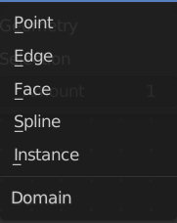
Properties

Domain
What element to duplicate.

Output

Geometry
Standard output.

Duplicate Index
The index of the duplicated elements.

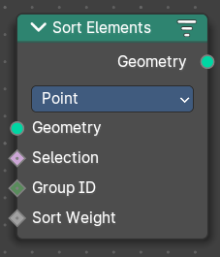
Sort Elements
The Sort Elements node rearranges geometry elements by changing their indices.

Input

Geometry
The input geometry.

Selection
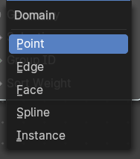
A selection of the input geometry. If left blank, all elements are sorted. Non selected elements will be keep their current indices.

Group ID
Group ID input value. A group is defined as all elements with the same group id. Elements with the same group ID are sorted together. If this is not a field, the node has no affect.

Sort Weight
The sorted values used to do the reordering. If this is not a field, the node has no affect.

Properties

Domain

Point
The fields are evaluated on points, control points, and vertices.

Face
The fields are evaluated on the edges of the mesh component.

Edge
The fields are evaluated on the faces of the mesh component.

Spline
The fields are evaluated on the splines in the curve component.

Instance
The fields are evaluated on the top-level instances. Realized instances are ignored.

Output

Geometry
The output geometry.

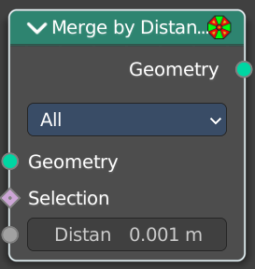
Merge by Distance
Welds the selected geometry below a given distance into one vertice.

Input

Geometry
The input geometry.

Selection
A selection of the input geometry.

Distance
The merge distance. Everything below this distance will be merged into one vertice.

Properties

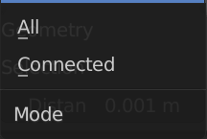
Mode

All
Merges all vertices in reach.

Connected
Merges just vertices that are connected by edges.

Output

Geometry
The output geometry.

Transform Geometry
Move, rotate or scale the geometry. The transformation is applied to the entire geometry, and not per element. For example, you can not rotate individual point cloud points with this node.

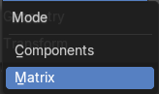
Mode
The transformation mode for the node.

Components
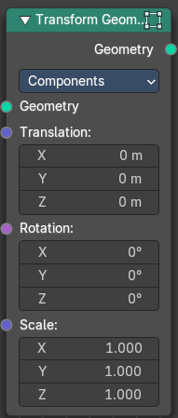
Uses single values and vectors.

Inputs

Geometry
Standard geometry input.

Translation
Translates the geometry in local space of the modified object.

Rotation
Euler rotation in local space.

Scale
Scale to transform the geometries in local space.

Output

Geometry
Standard geometry output.

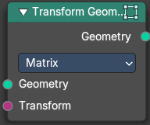
Matrix
Uses a matrix to transform.

Inputs

Geometry
Standard geometry input.

Transform
Transform matrix input

Output

Geometry
Standard geometry output.

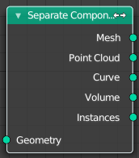
Separate Components
Splits a geometry into its components.

Inputs

Geometry
Geometry input.

Outputs

Mesh
Mesh component of the input geometry.

Point Cloud
Point cloud component of the input geometry.

Curve
Curve component of the input geometry.

Volume
Volume component of the input geometry.
In case that the input contains multiple volume instances, only the first volume component will be calculated.

Instance
The single instances of the geometry.

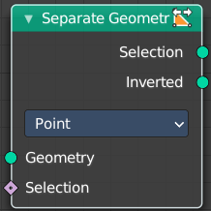
Separate Geometry
Separates a selection of a geometry into its own object.
Tip: when you combine it with the Compare Floats nodem then you get a more precise control of which parts are separated to a given output geometry.

Inputs

Geometry
Geometry input.

Selection
Selection input.

Properties

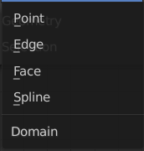
Domain
What kind of geometry to separate.
Note that when selecting a domain that doesn’t modify all components, the unmodified components will appear in both outputs.

Outputs

Selection
Separated selection.

Inverted
The inverted separated selection.

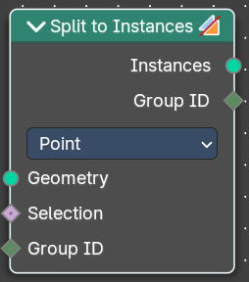
Split to Instances
This node allows splitting up a geometry into groups. A group is defined as all elements with the same group id.
The node supports meshes, curves, point clouds and instances. Note that it only works on the top-level geometry. It does not go into nested instances because it also generates new instances.

Inputs

Geometry
Geometry input.

Selection
Selection input.

Group ID
Group ID input value.

Properties

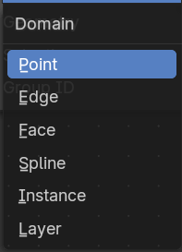
Domain
What kind of geometry to separate.
Note that when selecting a domain that doesn’t modify all components, the unmodified components will appear in both outputs.

Outputs

Instances
Instances output. An Instance per group.

Group ID
Group ID output value.

